English 1
SOAPSTone Analysis Form
Speaker | Who is the Speaker?  The voice that tells the story.  Non-Fiction – the author/speaker and any background information that might bear upon his/her text.  Fiction – the narrator, not the author, and any implied traits or characteristics that might influence the text.  Students should go beyond merely identifying the Speaker by name (occasionally, none will be given). Can you make some assumptions about this person? What class does the author come from? What  political bias can be inferred? What gender? Is the speaker reliable?
Occasion | What is the Occasion?  The time and the place of the piece; the context that encouraged the writing to happen.  Non-Fiction – the event that triggered the response  Fiction – the primary, specific event being discussed (summary)  What may have prompted the author to write this piece? What event led to  its publication or development?
Audience | Who is the Audience?  The group of readers/listeners to whom a piece is directed.  Non-Fiction and Fiction – the specific person, small group, or larger group a piece is aimed at  What assumptions can you make about the audience? Is it a mixed group in terms of race, politics, gender, social  class, relation, etc.? Who was the document created for? Does the speaker use language that is specific for a unique audience?
Purpose | What is the Purpose?  The reason behind the text?  Non-Fiction – what the Speaker wants the Audience to think or do as a result of reading/listening to the piece  Fiction – the larger “point” being examined in the piece; the “theme” presented  What is the speaker’s purpose? In what ways does the author convey this message? What seems to be the emotional state of the speaker? How is the speaker trying to spark a reaction in the audience? How is this document supposed to make you feel?
Subject | What is the Subject?  The general topic, content, and ideas contained in the text.  Non-Fiction and Fiction – the larger context of the text (related to Occasion and Purpose)  Students should go beyond the immediate occasion to discover the larger context or issue that eventually led to the triggering Occasion. This should be stated in a few words or a phrase.
Tone | What is the Tone?  The attitude of the author/Speaker.  Non-Fiction – the meaning imparted by the author that goes beyond the literal; how the author feels about the subject  Fiction – same as above, though it might require a distinction between author and narrator  How is the writer’s attitude revealed? What words or phrases show the speaker’s tone?

SOAPSTone can be used to begin discussions of literature, as reading checks, and/or in journals.
Students can use SOAPSTones to compare and contrast similar texts or types of texts.
SOAPSTones are especially well-suited to helping students determine topics for literary criticism.

SOAPSTone Examples

Political Cartoon (Non-Fiction, Non-Text)

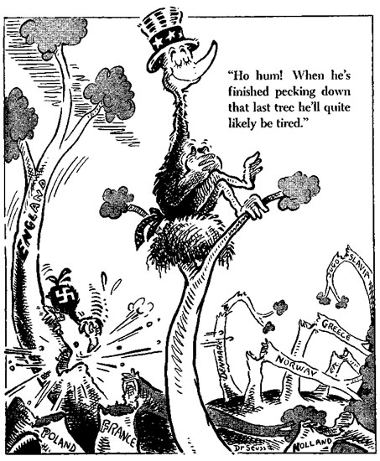

Speaker: Anti-isolationist political cartoonist [believe it or not, the artist is Dr. Seuss]
Occasion: the attacks on England by Nazi Germany
Audience: 1) other anti-isolationists
2) isolationists
Purpose: 1) support those who feel America should enter war
2)shame isolationists for their foolish views
Subject: World War II
Tone: mocking, humorous, satirical

SOAPSTone Examples
Gettysburg Address (Non-Fiction)
Four score and seven years ago our fathers brought forth on this continent, a new nation, conceived in Liberty, and dedicated to the proposition that all men are created equal.  Now we are engaged in a great civil war, testing whether that nation, or any nation so conceived and so dedicated, can long endure. We are met on a great battle-field of that war. We have come to dedicate a portion of that field, as a final resting place for those who here gave their lives that that nation might live. It is altogether fitting and proper that we should do this.  But, in a larger sense, we can not dedicate -- we can not consecrate -- we can not hallow -- this ground. The brave men, living and dead, who struggled here, have consecrated it, far above our poor power to add or detract. The world will little note, nor long remember what we say here, but it can never forget what they did here. It is for us the living, rather, to be dedicated here to the unfinished work which they who fought here have thus far so nobly advanced. It is rather for us to be here dedicated to the great task remaining before us -- that from these honored dead we take increased devotion to that cause for which they gave the last full measure of devotion -- that we here highly resolve that these dead shall not have died in vain -- that this nation, under God, shall have a new birth of freedom -- and that government of the people, by the people, for the people, shall not perish from the earth. | Speaker: President Abraham Lincoln – President  during Civil War  Occasion: Dedication of Cemetery near site of  Battle of Gettysburg (November 19,  1863)  Audience: 1)ostensibly, people attending  ceremony  2)supporters of the Union  3)those wavering in support of Union  4)critics of the war  5)Confederates  Purpose: 1)frame the Civil War as a conflict  regarding the essential ideals of the  US  2)state the importance of winning the  War  3)support believers in the justness of  the Union cause and bolster those  wavering in support  4)address critics of the War  5)show Confederates the resolve of  the Union  Subject: 1) Civil War  2) America in general  Tone: lofty, elevated, reverential, forceful,  definitive, powerful

Reveals the use of outside research (Occasion)

SOAPSTone Examples
“To Be or Not to Be” Soliloquy from Hamlet 3.1.55-89 (Fiction)

Speaker: Hamlet, disturbed Prince of Denmark – paranoid, depressed, seeking revenge
Occasion: 1) the appearance of his “friends” Rosencrantz and Guildenstern, who Hamlet no longer
trusts
2) Hamlet’s angst at watching the First Player
3) the formations of Hamlet’s plans
Audience: 1) if Hamlet feels he is alone: himself
2) if Hamlet feels he is being watched: Claudius, Polonius, and possibly Ophelia
Purpose: 1) if Hamlet feels he is alone: to work out his thoughts and further castigate himself
2) if Hamlet feels he is alone: to ponder suicide and/or murder
3) if Hamlet feels he is being watched: further his “antic disposition”
Subject: 1) life, the universe, and everything
2) God, religion, justice, and punishment
3) suicide and murder
4) the consequences of death and/or murder
Tone: high, elevated, depressed, moody, troubled, confused, “antic”

Notice that Shakespeare is not the Speaker
Note the complexity that is revealed through the use of SOAPSTone

